**1. Initialise a Git Repository and Make Initial Commit**

**Q1a) Create a new directory named projectrepo.**

**Q1b) Initialise a Git repository in this directory using the appropriate command.**

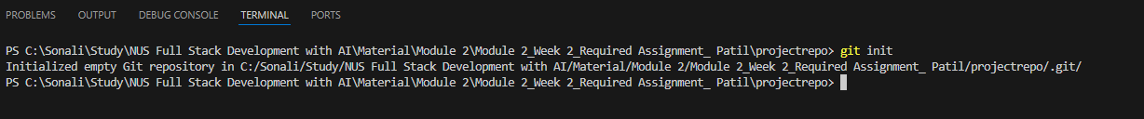

**Q1c) Create a README.md file, add some introductory content, and save it.**

**Q1d) Stage and commit the README.md file with an appropriate commit message.**

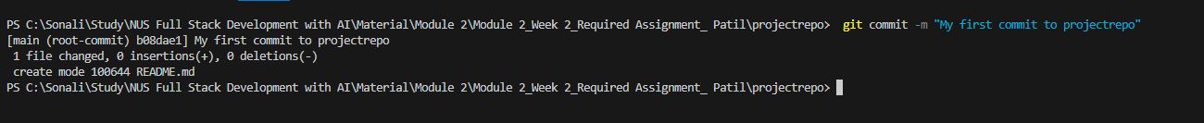

**2. Create a New Branch and Implement a Feature**

**Q2a) Create a new branch named featurex and switch to it.**



**Q2b) In featurex, add a new file named feature.py and write a simple function (e.g., a function that adds two numbers).**

**Q2c) Stage and commit feature.py with an appropriate commit message.**

**Q2d) Switch back to the main branch and confirm that feature.py is not in the main branch.**

**3. Make Changes on the Main Branch to Create a Merge Conflict**

**

**Q3b) Make Changes on the Main Branch and Feature Branch**

**Q3c) Merge the feature branch into the main branch.**

**Q3d) Resolve the merge conflict.**

**4. Work with a Remote Repository**

**Q4a) Create a remote repository (e.g., on GitHub) named projectrepo.**

**Q4b) Connect your local projectrepo to this remote repository using git remote add.**

**Q4c) Push the main branch to the remote repository.**

**Q4d) Create a new branch named collaborator update in the remote repository by pushing a new commit to it.**

**Q4e) Return to your local repository, pull the latest changes, and merge collaborator update into main. - Remote changes are pulled successfully into the local repository, and branches are merged successfully with no conflicts.**

**Q4f) Push the final merged state to the remote repository.**

**___________________________________________________________________________________**

**For the future reference, All the code is pushed to remote repository (https://github.com/SSKRCP/projectrepo)**

